WEDE5020-POE-Part1

Jarrud Fredrick Cochrane

ST10266083

2023

Table of contents

|  |  |
| --- | --- |
| Ideation and Sourcing Assets | Pg 3 - 5 |
| Website Page and Content Structure | Pg 6 |
| Reference list | Pg 7 |

Ideation and Sourcing Assets

Give Power To SA

* Brighter days ahead

Business idea

Give Power to SA is Non-profit organisation (NPO) that wants to provide electricity to previously disadvantaged people in South Africa by providing the previously disadvantaged with access to electricity through solar panels installations.

WHY?

Certain South Africa’s have been previously disadvantaged through Apartheid in the past and have been segregated into areas that are not provided with power. Give Power to SA want to correct the mistakes from the past and give previously disadvantaged people opportunities in South Africa. Studies have shown that up to 11% of South Africans do not have access to electricity. Electricity is essential for the well-being of South Africans. (Kolver, 2013)

Bibliography

Kolver, L., 2013. 11% of SA households still without electricity. 14 November , p. 1

How?

Give Power to SA will be funded by overseas investors that want to grow their business name by providing solar panels to previously disadvantaged South Africans to create a good business image in the public relations for them. Give Power to SA also going to host charities to be able to provide previously disadvantaged South Africans with the right resources. We will also invest some of our own money to help. We will go to the areas and investigate and see if it is safe to do so, then we will need to educate South Africans on how to use Solar panels correctly.

Conclusion

In conclusion Give Power to SA (NPO) is a business that will improve the lives of previously disadvantaged South Africans with access to electricity that will provide people with opportunities to gain experience and study. This will help with South Africans education and in future reduce unemployment rate. We will go to the previously disadvantaged areas and will scan the areas, so the people can register for the panels. We will educate them on the solar panels and the opportunities we are providing them with. Once we have verification from the investor we will go ahead and install the panels safely in places where the Solar panels will be safe and will last. This all will be done with one goal in mind. Improving the lives of South Africans.

Website assist

Figure 1



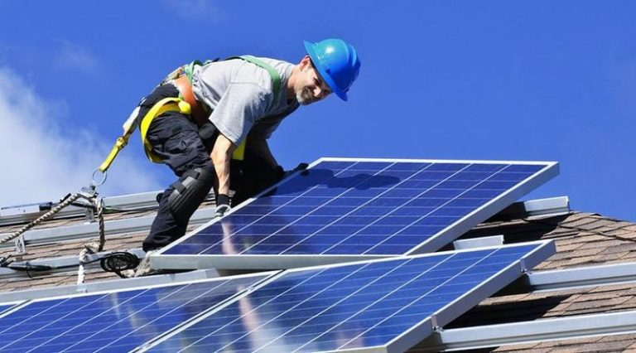

**Figure 2**

Website Page and Content Structure

1. Homepage

i. Logo.

ii. Slogan.

iii. Links to other pages.

iv. Full-width photo.

v. Summary of main activities of the organisation.

vi. Basic contact info.

vii. Copyright / Year.

1. About Us

Brief Summary

1. Contact us.

i. Email.

ii. Contact number.

1. Latest NEWS
2. Latest news constantly getting updated.
3. How to support us
4. Brief summary on how you can support us.

References list

From essay.

Kolver, L.2013. 11% of SA households still without electricity, Creamer Media, 14th November 2013[Blog].Available at: [11% of SA households still without electricity (engineeringnews.co.za)](https://www.engineeringnews.co.za/article/11-of-sa-households-still-without-electricity-2013-11-14/rep_id:4136#:~:text=According%20to%20its%20General%20Household%20Survey%20%28GHS%29%2C%20in,578%20005%2C%20households%20accessed%20electricity%20informally%20or%20illegally.) [Accessed 1 April 2023]

**Figure 1: *What to Consider before Installing Rooftop Solar Panels*?, 2020.** [**How to Ensure Best Solar Panel Installations | Top Choices (topsolarquote.com)**](https://topsolarquote.com/solar-panel-installations/) **[ Assessed 12 June 2020].**



**Figure 2: BrandCrowd. 2011. BrandCrowd. Version 1.911.[App].**

**Available at:** [Logos - Thousands of Handcrafted Logos to Customise & Make Your Own (brandcrowd.com)](https://www.brandcrowd.com/maker/logos?text=Give%20power%20to%20SA&isFromLogoHome=true#show-onboarding-modal)

(Accessed 1 April 2023).